My SQL
Data Set
- Housing Data.csv

File Location
C:\Noble\Training\Course Content\Power BI\Presentation\Project\House Price Analyis\Housing Data.csv

Open the data file in Excel

Data - > From Text -> File Name -> Next
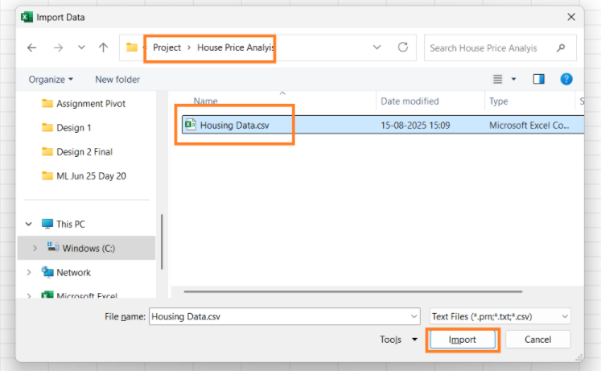

Load the File
Click the button Load to load the file
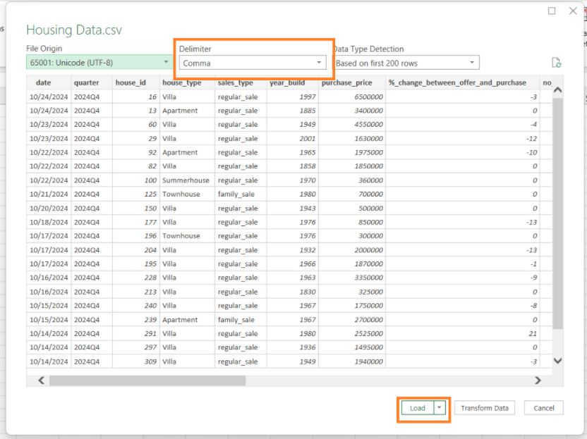

Data Loaded

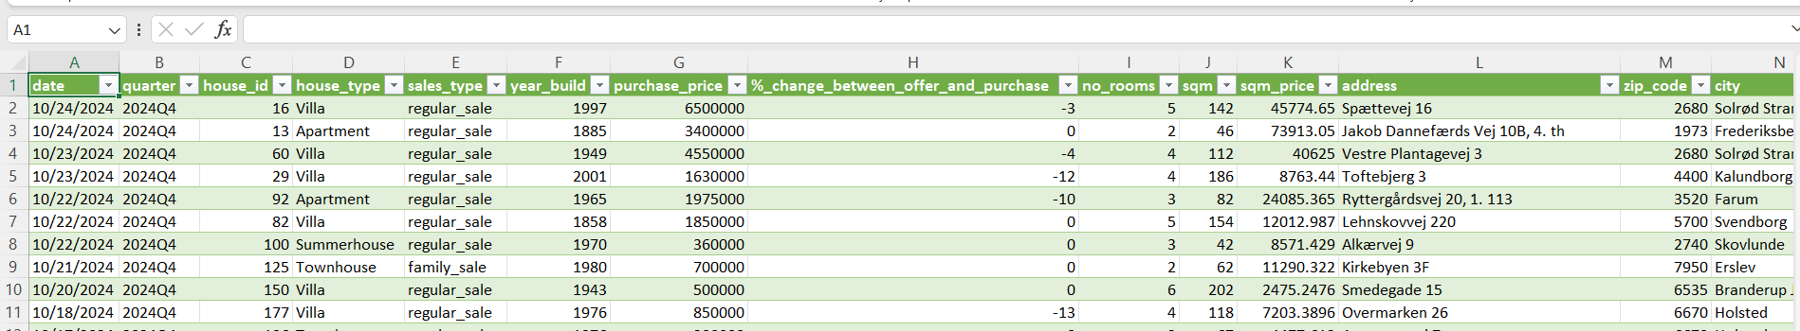

Create a new Database to load the .csv file (Housing Data.csv)

DROP DATABASE IF EXISTS HOUSE;

CREATE DATABASE HOUSE;

USE HOUSE;

Load the file into MYSQL database

Right Click Tables -> Table Data Import Wizard

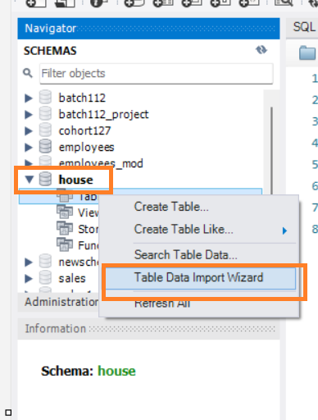

Click Browse
Select the folder where the data is available
Select Housing Data.csv file Name
Click Open

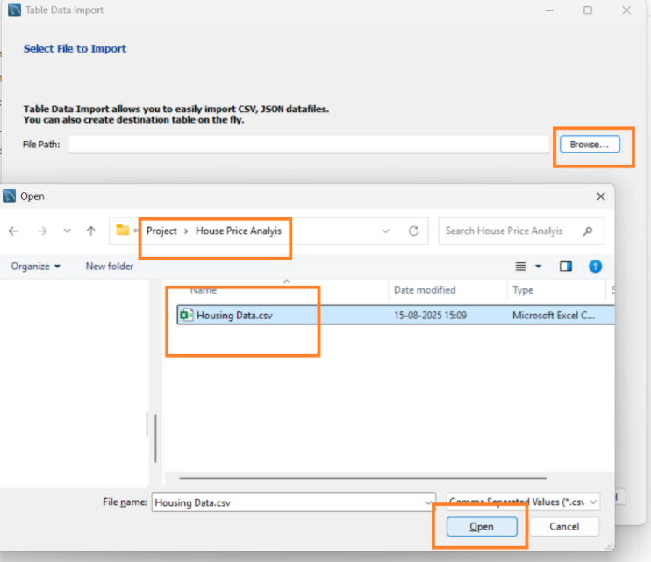

Click Next on Select File to Import
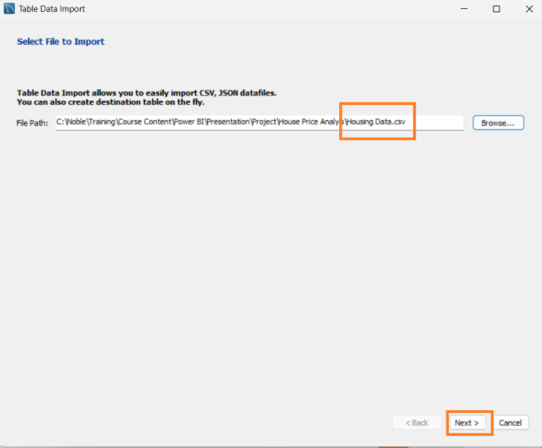

Data Base name and Table Name Auto populate – Update any change required
Please ensure the Drop table if exists check Box is checked
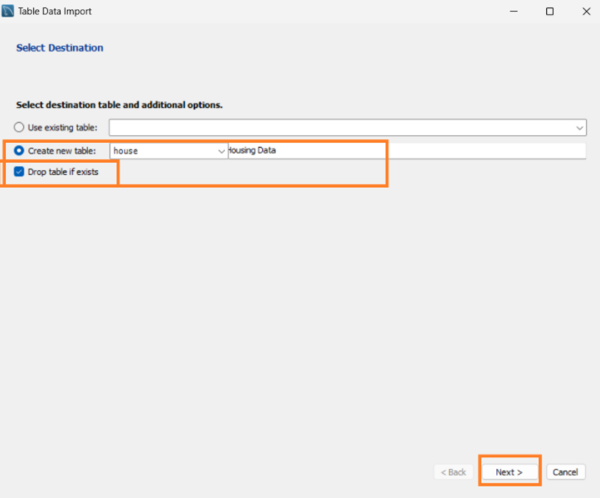

Proceed with Auto populated data types
Note: If we make any change in the data type specially date etc, if it not matches with data , data won’t be loaded

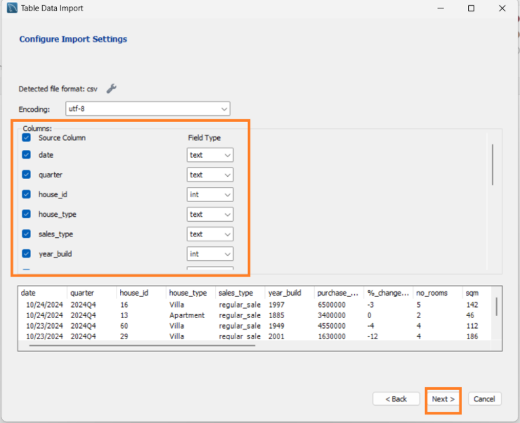

Use Default and click Next
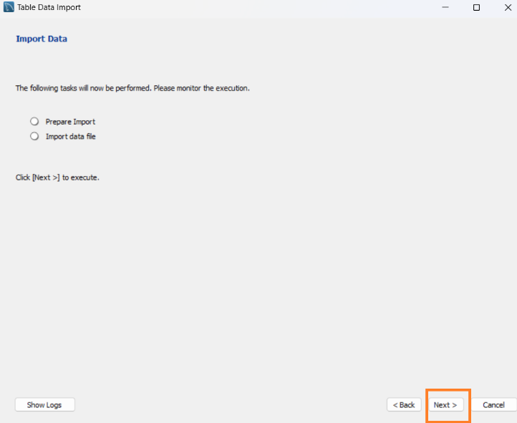

Once the Data import is complete click Next 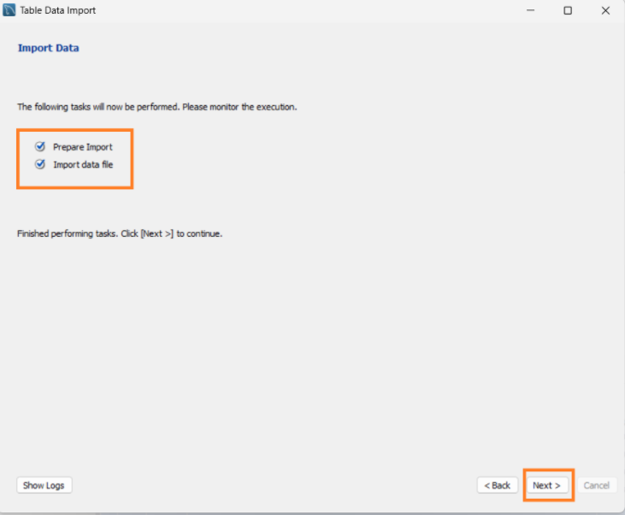

Click Finish
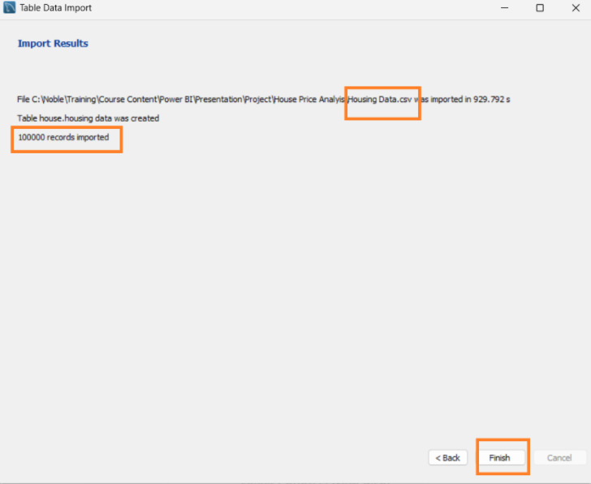

Count the number of records in each table

USE HOUSE;
select count(*) from `housing data`;

